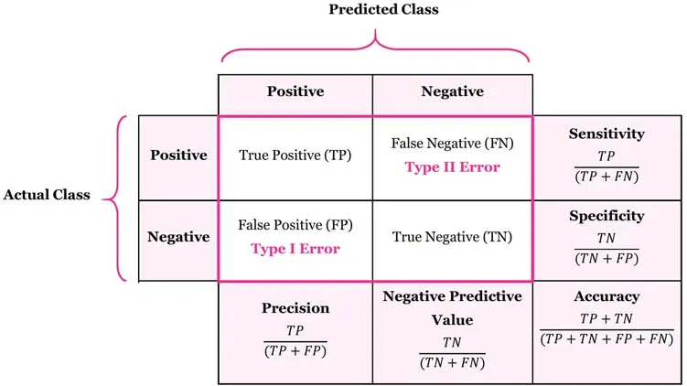

 |  | Predictive Cases
 |  | Predicted_U | Predicted_N | Predicted_R
Actual Case | Actual_U | 120  tpU | 42  errUN | 18  errUR | Total Actual Positive of U  = tpU + errUN + errUR | $$Recall or Sensitivity of U = \frac{tpU}{tpU+errUN+errUR}$$ | $$F1 of U = 2×\frac{Precision_{U} ×Sensitivity_{U}}{Precision_{U}+Sensitivity_{U}}$$
 | Actual_N | 60  errNU | 612  tpN | 48  errNR | Total Actual Positive of N  = tpN + errNU + errNR | $$Recall or Sensitivity of N = \frac{tpN}{tpN+errNU+errNR}$$ | $$F1 of N = 2×\frac{Precision_{N} ×Sensitivity_{N}}{Precision_{N}+Sensitivity_{N}}$$
 | Actual_R | 45  errRU | 90  errRN | 165  tpR | Total Actual Positive of R  = tpR + errRU + errRN | $$Recall or Sensitivity of R = \frac{tpR}{tpR+errRU+errRN}$$ | $$F1 of R = 2×\frac{Precision_{R} ×Sensitivity_{R}}{Precision_{R}+Sensitivity_{R}}$$
 |  | Total Predicted Positive of U  = tpU + errNU + errRU | Total Predicted Positive of N  = tpN + errUN + errRN | Total Predicted Positive of R  = tpR + errUR + errNR
 |  | $$Precision of U = \frac{tpU}{tpU+errNU+errRU}$$ | $$Precision of N = \frac{tpN}{tpN+errUN+errRN}$$ | $$Precision of R = \frac{tpR}{tpR+errUR+errNR}$$ |  | $$Accuracy = \frac{tpU+tpN+ tpR}{Total}$$

 |  | Predictive Cases
 |  | Predicted_U | Predicted_N | Predicted_R
Actual Case | Actual_U | 120  tpU | 42  errUN | 18  errUR | Total Actual Positive of U  = tpU + errUN + errUR | $$Recall or Sensitivity of U = \frac{tpU}{tpU+errUN+errUR}$$ | $$Specificity of U = \frac{tpN+errNR+errRN+tpR}{Total Actual Positive of N+ Total Actual Positive of R}$$
 | Actual_N | 60  errNU | 612  tpN | 48  errNR | Total Actual Positive of N  = tpN + errNU + errNR | $$Recall or Sensitivity of N = \frac{tpN}{tpN+errNU+errNR}$$ | $$Specificity of N = \frac{tpU+errUR+errRU+tpR}{Total Actual Positive of U+ Total Actual Positive of R}$$
 | Actual_R | 45  errRU | 90  errRN | 165  tpR | Total Actual Positive of R  = tpR + errRU + errRN | $$Recall or Sensitivity of R = \frac{tpR}{tpR+errRU+errRN}$$ | $$Specificity of R = \frac{tpU+errUN+errNU+tpN}{Total Actual Positive of U+ Total Actual Positive of N}$$
 |  | Total Predicted Positive of U  = tpU + errNU + errRU | Total Predicted Positive of N  = tpN + errUN + errRN | Total Predicted Positive of R  = tpR + errUR + errNR
 |  | $$PPV or Precision of U = \frac{tpU}{tpU+errNU+errRU}$$ | $$PPV or Precision of N = \frac{tpN}{tpN+errUN+errRN}$$ | $$PPV or Precision of R = \frac{tpR}{tpR+errUR+errNR}$$ |  | $$Accuracy = \frac{tpU+tpN+ tpR}{Total}$$

$$Negative Predictive Value (NPV) of U = \frac{tpN+errNR+errRN+tpR}{Total Predicted Positive of N+ Total Predicted Positive of R}$$ | $$Negative Predictive Value (NPV) of N = \frac{tpU+errUR+errRU+tpR}{Total Predicted Positive of U+ Total Predicted Positive of R}$$ | $$Negative Predictive Value (NPV) of R = \frac{tpU+errUN+errNU+tpN}{Total Predicted Positive of U+ Total Predicted Positive of N}$$

 |  | Predicted_UR | Predicted_N
Actual Case | Actual_UR | 120+18+45+165  TP | 42+90  FN | Total Actual Positive of UR  = TP + FN | $$Recall or Sensitivity of UR = \frac{TP}{TP+FN}$$ | $$Specificity of UR = \frac{TN}{TN+FP}$$ | $$F1 of UR = 2×\frac{Precision_{UR} ×Sensitivity_{UR}}{Precision_{UR}+Sensitivity_{UR}}$$
 | Actual_N | 60+48  FP | 612  TN | Total Actual Positive of N  = FP + TN | $$Recall or Sensitivity of N = \frac{TN}{TN+FP}$$ | $$Specificity of N = \frac{TP}{TP+FN}$$ | $$F1 of N = 2×\frac{Precision_{N} ×Sensitivity_{N}}{Precision_{N}+Sensitivity_{N}}$$
 |  | Total Predicted Positive of UR  = TP + FP | Total Predicted Positive of N  = FN + TN
 |  | $$PPV or Precision of UR = \frac{TP}{TP+FP}$$ | $$PPV or Precision of N = \frac{TN}{TN+FN}$$ |  | $$Accuracy = \frac{TP+TN}{TP+TN+FP+FN}$$
 |  | $$Negative Predictive Value$$  $$(NPV) of UR = \frac{TN}{TN+FN}$$ | $$Negative Predictive Value$$  $$(NPV) of N = \frac{TP}{TP+FP}$$

